**🚀 EC2 Instance Setup using AWS CLI & Terraform**

**1️⃣ Install AWS CLI**

**📌 For Linux**

Run the following commands:

curl "https://awscli.amazonaws.com/AWSCLIV2.pkg" -o "AWSCLIV2.pkg"

sudo installer -pkg AWSCLIV2.pkg -target /

aws --version

**📌 For Windows**

1. Download **AWS CLI v2** from: [AWS CLI Download](https://aws.amazon.com/cli/)
2. Run the installer and follow the setup
3. Verify installation:

aws --version

**2️⃣ Configure AWS CLI**

Run:

aws configure

Enter:

* **AWS Access Key ID**: your-access-key
* **AWS Secret Access Key**: your-secret-key
* **Default region**: us-east-1 (or your preferred region)
* **Default output format**: json

To verify your configuration, run:

aws sts get-caller-identity

**3️⃣ Install Terraform**

**📌 For Linux**

sudo yum install -y yum-utils

sudo yum-config-manager --add-repo https://rpm.releases.hashicorp.com/RHEL/hashicorp.repo

sudo yum install terraform -y

terraform -version

**📌 For Windows**

1. Download Terraform from: Terraform Download
2. Extract and add the path to the system environment variables
3. Verify installation:

terraform -version

**4️⃣ Create a .env File**

Create a .env file in your working directory:

touch .env

Add the following details:

AWS_ACCESS_KEY_ID=your-access-key

AWS_SECRET_ACCESS_KEY=your-secret-key

AWS_REGION=us-east-1

Load the environment variables:

source .env

**5️⃣ Create Terraform Configuration for EC2 Instance**

Create a new file main.tf:

provider "aws" {

region = "us-east-1"

}

resource "aws_instance" "app_server" {

ami = "ami-088b41ffb0933423f" # Replace with a valid AMI

instance_type = "t2.micro"

key_name = "your-key-pair"

tags = {

Name = "MyTerraformInstance"

}

}

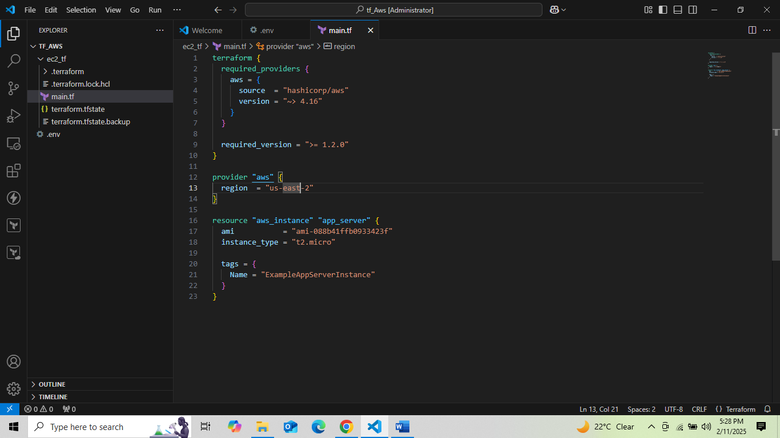

**6️⃣ Initialize and Apply Terraform**

Run:

terraform init

terraform plan

terraform apply

Confirm by typing yes when prompted.

Output :

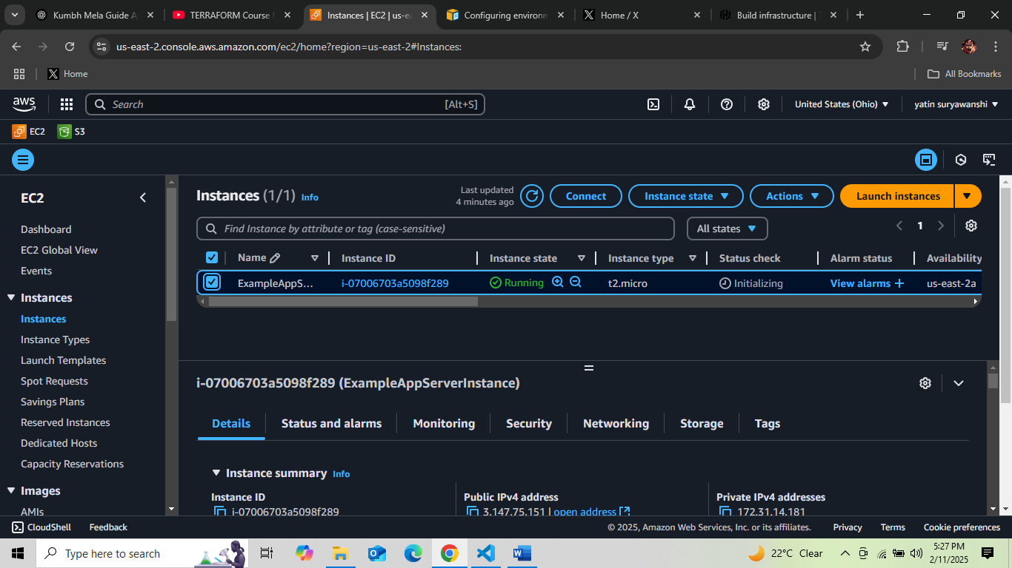

**7️⃣ Destroy the EC2 Instance (Optional)**

If you want to delete the instance, run:

terraform destroy

Confirm by typing yes when prompted.

✅ **Congratulations!** You have successfully created an EC2 instance using AWS CLI and Terraform. 🎉